Experiment 6.3
Sampling Theorem Verification
Program (MATLAB)
% Sampling Theorem Verification
clc;
clear;
close all;
% Signal parameters
fm = 5; % Signal frequency (Hz)
fs = 20; % Sampling frequency (Hz)
t = 0:0.001:1; % Continuous time

% Continuous signal
x = sin(2*pi*fm*t);
% Sampled signal
n = 0:1/fs:1;
xs = sin(2*pi*fm*n);
% Plotting
figure;
subplot(2,1,1);
plot(t,x,'LineWidth',2);
grid on;
title('Continuous-Time Signal');
xlabel('Time (s)');
ylabel('Amplitude');
subplot(2,1,2);
stem(n,xs,'filled');
grid on;
title('Sampled Signal (f_s = 20 Hz)');
xlabel('Time (s)');
ylabel('Amplitude');
Output Generated Graph
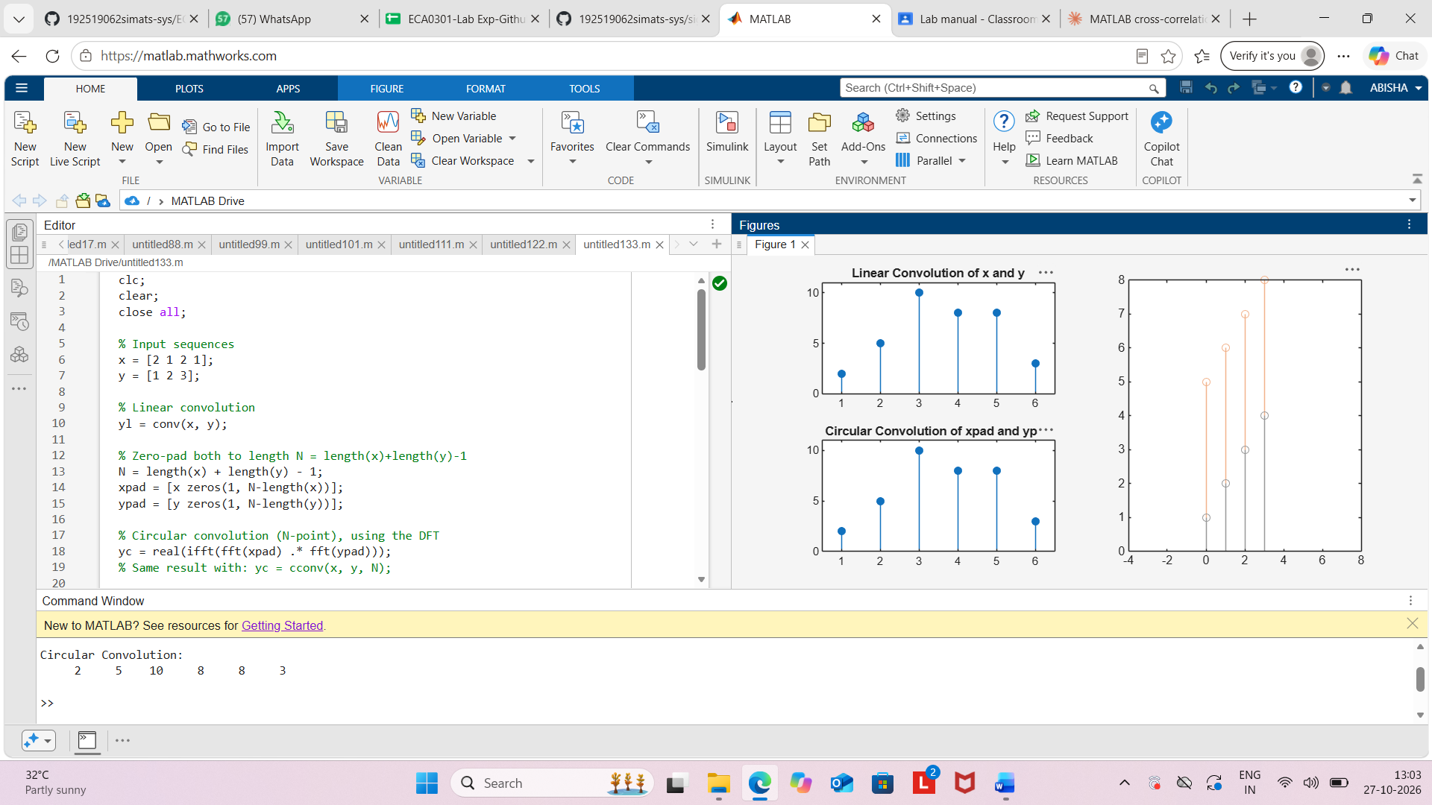
Result
The Sampling Theorem was verified using MATLAB by sampling a 5 Hz sinusoidal signal at
a sampling frequency of 20 Hz. Since the sampling frequency was greater than the Nyquist
rate (10 Hz), the signal was sampled without aliasing and could be reconstructed accurately.

